Ideation Phase

Empathize & Discover

Date | 19 February 2026
Team ID | LTVIP2026TMIDS89796
Project Name | Heritage Treasures: An In-Depth Analysis of UNESCO World Heritage Sites in Tableau
Maximum Marks | 4 Marks

Introduction:
The Empathy Map is a human-centered design tool that helps us understand the thoughts, emotions, behaviors, and needs of our target users. In this project, we focus on the student persona to uncover the real challenges faced in the current educational system, particularly around academic tracking and communication.

By analyzing what students see, hear, think, feel, and do, this Empathy Map highlights their pain points and expectations. It serves as the foundation for designing features within the Educational Organisation Using ServiceNow project that are meaningful, user-friendly, and address genuine concerns. The insights gathered here guided us in creating a more efficient, transparent, and student-focused digital experience.

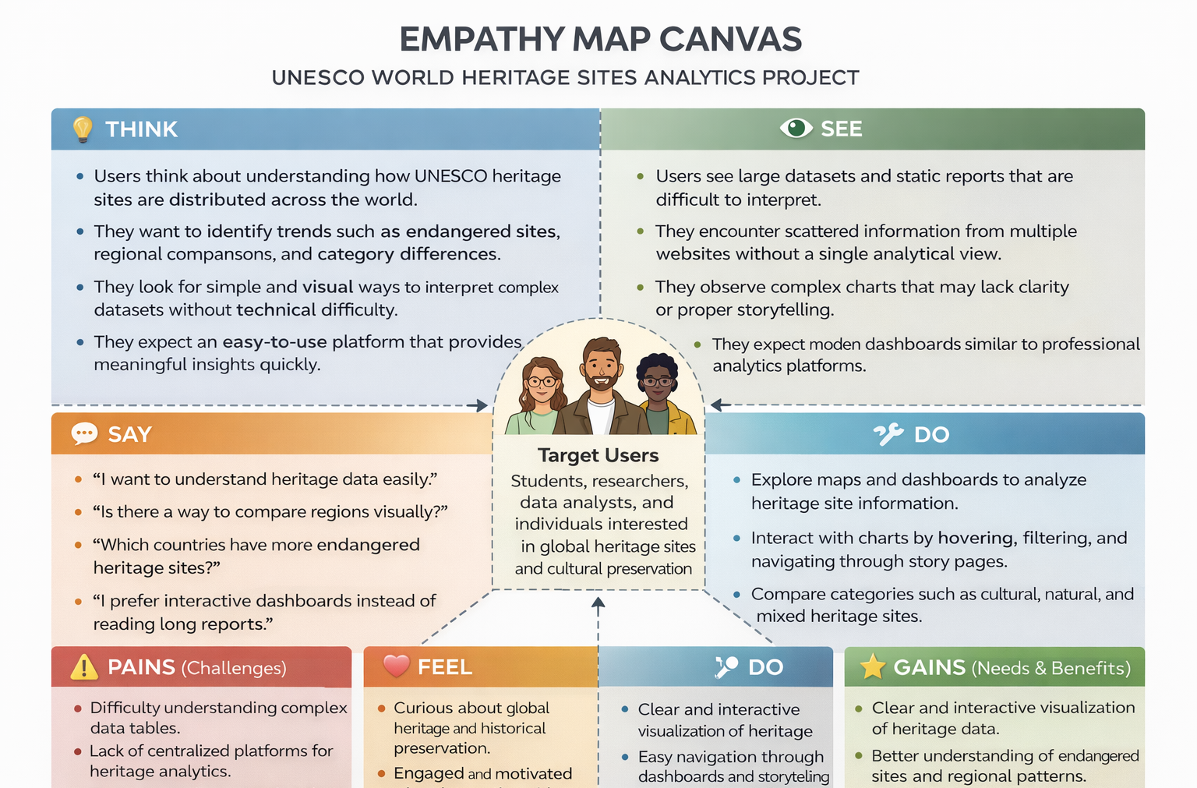

Reference: https://www.mural.co/templates/empathy-map-canvas

